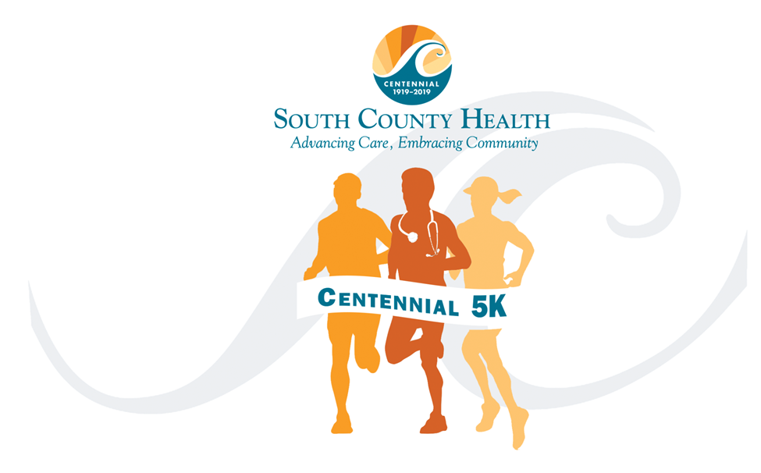

Centennial 5K
Fundraising Planner

About South County Health and what we are raising money for:
Welcome to the Team that’s saving lives!
South County Health is a full-service healthcare resource located in southern Rhode Island, offering a comprehensive range of advanced inpatient, outpatient and home health services delivered by highly trained professionals. Quality care is our primary goal. We are guided by five core values: caring, respect, integrity, collaboration and excellence.
This year’s event will support Cancer Services at South County Hospital.
Our region’s cancer incidence rates – already among the highest in Rhode Island – are projected to continue to rise as our community ages. By 2020, more than 900 residents of Washington County are expected to be diagnosed with cancer every year. South County Hospital’s Oncology Rehab Program offers important physical and psychological rehabilitation, so survivors can recover more quickly and more completely than they otherwise would. Our rehabilitation care, based on conventional medicine, is offered to patients by a knowledgeable and sensitive staff, specially trained to treat survivors of all forms of cancer.
South County Hospital recognizes the importance of providing all patients with access to services they need from diagnosis through treatment, rehabilitation, and survivorship care.
Fundraising Planner
Everything You Need to Know About Fundraising
This planner is designed to provide you with a rough outline of the steps to have fundraising success. At the core of this plan is identifying your donor network, and efficiently and effectively asking for their help to support Cancer Services. Plan ahead, have fun, use the resources we give you, and you will be a successful fundraiser!

Customize Your Fundraising Plan
- Create a Fundraising Goal for you and your Team
- Customize your fundraising webpage
- Brainstorm potential donors and create a list that includes their contact information.
  - Identify key people within your network to make a larger personal ask.
- Tell your friends and family about your plan and invite them to join you.
- Announce your event participation through e-mail and social media. Include your fundraising website in an update on Facebook, LinkedIn, Twitter etc.
- Tell at least one person a day about your commitment. The more people who know, the more people will donate!
- Recognize your donors by tagging them in thank yous on Facebook, sending them a short note, or picking up the phone to give a quick thank you call.
- Follow up with each donor to ask if their company offers matching gifts.
- Plan a fundraising event or party
  - Use holidays, events and seasons – your birthday, Super Bowl, Academy Awards, Saint Patrick’s Day! Start your brainstorming now –
  - Have a backyard fundraising bash, pumpkin-carving contest or holiday bazaar.
- Post regular updates on your progress, and remind them of your individual goal.
- Send an update to your online friends. “Almost there!”
- Encourage friends and family to forward your fundraising website on to others
- Congratulate yourself on making a difference in the lives of our patients!
Sample Campaign Plan | Number sent | Plan | Actual | Average Gift | Expected Return | Actual Return
A. Number of people to send emails | 50 |  |  | $50.00 | $375.00
Expecting an average 15% return. National average gift is $63. To be conservative, we have listed the average gift as $50.
B. Number of people to reach through social networking | 200 |  |  | $50.00 | $1,500.00
Grand Total |  |  |  |  | $1,875.00
Sample Email
Dear Friends and Family,
I’ve committed myself to running the South County Health Centennial 5K on May 11 to support Cancer Care at South County Hospital. South County Hospital has been providing life-saving care to the residents of South County and beyond since 1919. Generations of compassionate people have nurtured the growth of South County Hospital and supported its evolution as a cornerstone of the integrated health system known today as South County Health.
My motivation and commitment to this cause are very personal. (Insert your own story or we can provide one for you)
So now I ask you to please make a donation in support of my efforts to raise money for cancer services at South County Hospital. My goal is to raise $X. I’m improving the quality of my life by participating and with your support; I can help improve the quality of life for patients and their families
You can donate by visiting: [insert link to personal fundraising page] and donating generously to South County Health. Every bit counts!
Donations are tax deductible. Thank you for your support!
Warm regards,
Your name

Sample Social Media Posts:
Don’t forget to personalize the posts!
Help me save lives! I’m training for the South County Health Centennial 5K, and I need your help to cross the finish line. Please support my efforts to support Cancer Services at South County Hospital by visiting my website [insert link to personal fundraising page].
Who will be the first to donate to help me! Visit my donation page now: [insert link to personal fundraising page]
How long does it take to run 3.1 miles? I’m going to find out: [insert link to personal fundraising page]

South County Health Facts and Figures
- South County Health's Cancer Center is accredited with commendation by the Commission on Cancer (CoC) of the American College of Surgeons. Considered to be the gold standard for cancer programs, accreditation by the CoC means patients can be assured they will receive high quality patient-centered care.
- South County Hospital has earned straight A’s for hospital quality and patient safety since 2012. South County Hospital is one of only 63 hospitals nationwide to attain the straight A rating and the only hospital in Rhode Island to earn straight A’s since 2012.
- South County Hospital was one of only two hospitals in Rhode Island to receive a 2015, 2016, and 2017 Women’s Choice Award® for outstanding care in obstetrics. This designation is one-of-a-kind and identifies the country’s best healthcare institutions based on female patient satisfaction, clinical excellence, and what women say they want from a hospital.
- South County Hospital has been recognized as a High Performing Hospital in the U.S. News & World Report’s 2018-19 edition of “Best Hospitals”. It was the only hospital in Rhode Island to receive the “High Performing” rating for knee replacement surgery.

Sample Text Message:
Don’t forget to personalize the posts!
Help me save lives! I’m training for the South County Health Centennial 5K, and I need your help to cross the finish line. Please support my efforts to support Cancer Services at South County Hospital by visiting my website. Who will be the first to donate to help me! Visit my donation page now: [insert link to personal fundraising page]

